**Home Price**

We use a linear regression algorithm to predict home price

We use a dataset on Monroe Twp., NJ (USA)

Given these home prices find out the price of whose area is,

3300 Square feet

5000 Square feet

Area in from of scatter plot like this thus the red marker shows the available data points

Now we can draw a blue line that best fits these data points

We calculated:

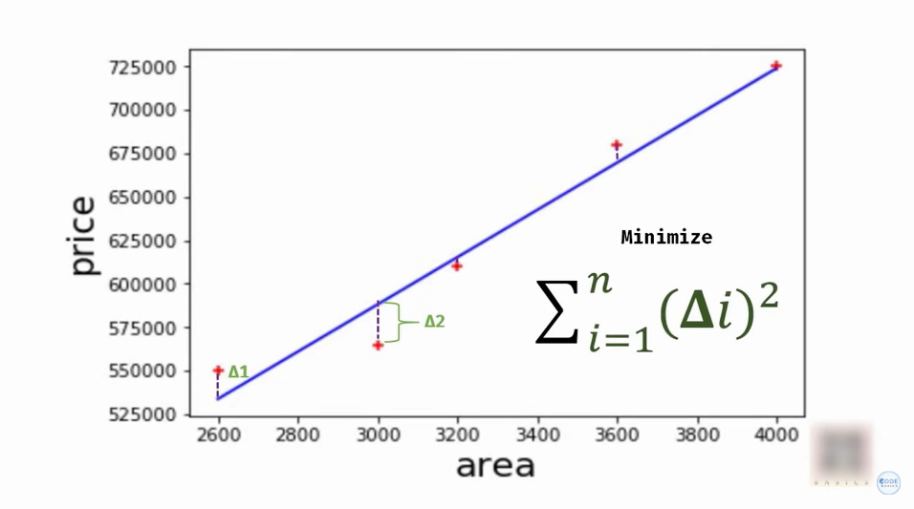

We actually predicted by linear regression

We can square individual errors and sum them ups and minimize those

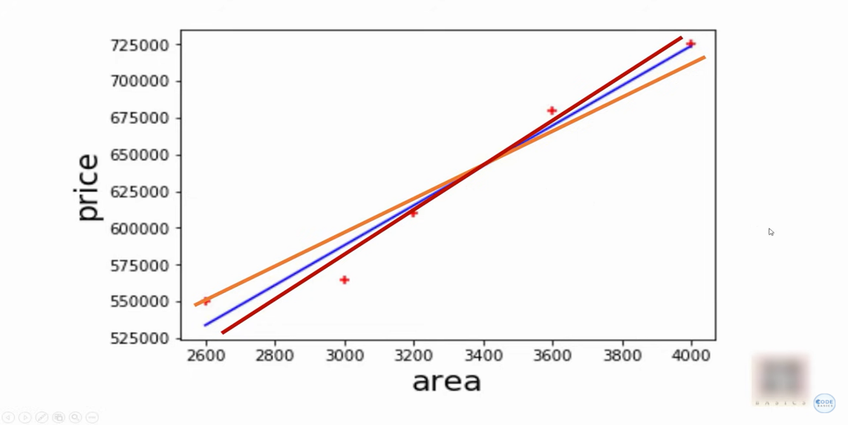

We do this procedure on all these lines so orange, red, and blue lines

Blueline giving me minimum error

The formula for Linear regression:

Y=mx +b

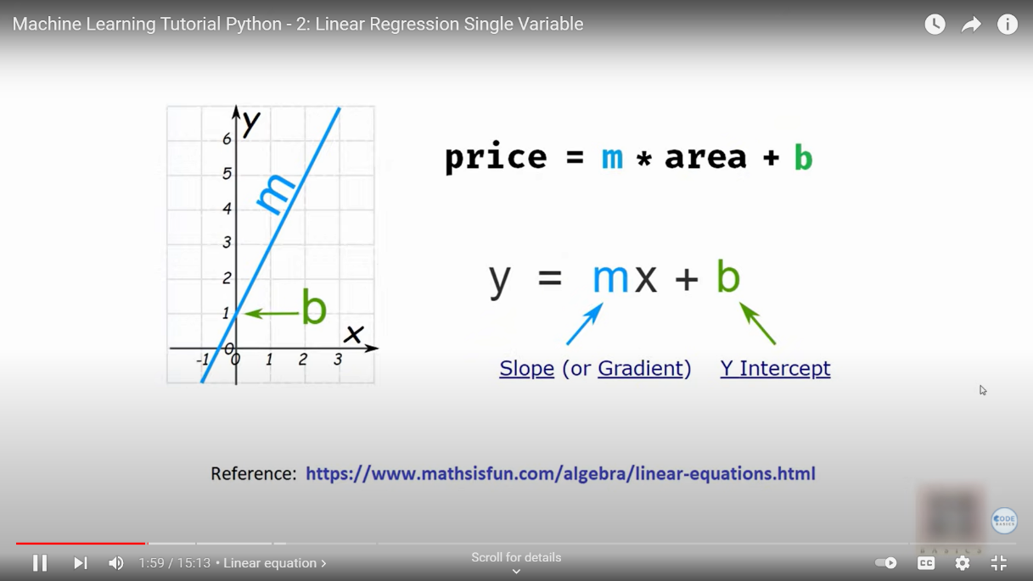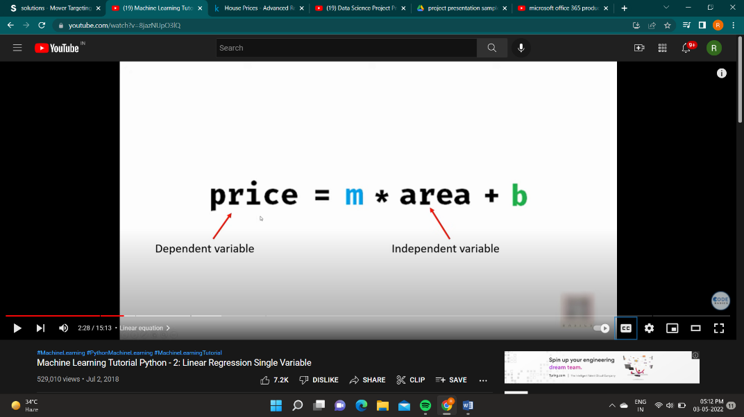

Now We going to write code

import NumPy as np

import matplotlib.pyplot as plt

from sklearn import linear model

# after import CSV file

import pandas as pd

df = pd.read_csv('Houseprice.csv')

df

#plot scatter plot get an idea of the distribution o f data point

%matplotlib inline # its used to draw the plots

#We plot area and price

plt.xlabel("Area")

plt.ylabel('Price')

plt.title('Houseprice')

Plt.scatter(area,price)

We want to import linear regression

Reg=linear_model.LinearRegression()

We will fit my data

Fit() means your training liner regression is available datapoints

reg.fit(df[['Area']],df.Price)

its means no error on this model we ready to predict

After we trained the liner regression model calculates the coefficient and intercept

reg.predict([[3300]])

The coefficient is M:

reg.coef_

Intercept is B:

Reg.intercept_

Calculate the formula in given Square feet

Y=m*x + b

135.78767123*3300 +180616.43835616432

OUT:- 628715.7534151643